1)Can PCA be used for feature selection?
2)How PCA is used for dimensionality reduction?
3)How is the first principal component axis selected in PCA?
4)What's the difference between PCA and t-SNE?
5)Highlight the major challenge associated with high dimensional data
6)Is it important to standardize the data before applying PCA?
7)Is rotation necessary in PCA? If yes, Why? Discuss the consequences if we do not rotate the components?
8)What are the assumptions taken into consideration while applying PCA?
9)What are the properties of Principal Components in PCA?
10)What does a Principal Component in a PCA signify? How can we represent them mathematically?

1)Feature selection refers to choosing a subset of the features from the complete set of features.
In PCA, we obtain Principal Components axis, this is a linear combination of all the original set of feature variables which defines a new set of axes that explain most of the variations in the data.
Therefore while PCA performs well in many practical settings, it does not result in the development of a model that relies upon a small set of the original features and so for this reason, PCA is not a feature selection technique.
2)Principal Component Analysis (PCA) is an unsupervised, non-parametric statistical technique primarily used for dimensionality reduction in machine learning.
Principal component analysis is a useful technique when dealing with large datasets. In some fields, (bioinformatics, internet marketing, etc) we end up collecting data which has many thousands or tens of thousands of dimensions. Manipulating the data in this form is not desirable, because of practical considerations like memory and CPU time. However, we can't just arbitrarily ignore dimensions either. We might lose some of the information we are trying to capture!
Principal component analysis is a common method used to manage this tradeoff. The idea is that we can somehow select the 'most important' directions, and keep those, while throwing away the ones that contribute mostly noise.
For example, this picture shows a 2D dataset being mapped to one dimension:
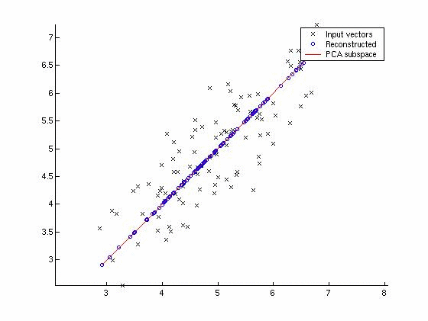
Note that the dimension chosen was not one of the original two: in general, it won't be, because that would mean your variables were uncorrelated to begin with.
We can also see that the direction of the principal component is the one that maximizes the variance of the projected data. This is what we mean by 'keeping as much information as possible.'
3)n Principal Component Analysis (PCA) we look to summarize a large set of correlated variables (basically a high dimensional data) into a smaller number of representative variables, called the principal components, that explains most of the variability in the original set.
The first principal component axis is selected in a way such that it explains most of the variation in the data and is closest to all n observations.
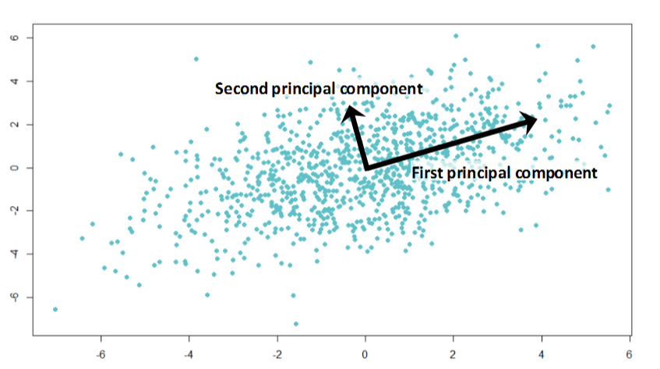
4)PCA:
  - It is a mathematical technique based on linear algebra.
  - Tries to preserve global structure/Shape.
  - It does not take into consideration the distance between data points but the direction of maximum variability.
  - Is a linear technique: reduce the dimension of the data when the linear correlations are strong.
- t-SNE:
  - Is based on probabilities.
  - Tries to preserve the local structure by taking into account the distance between the point.
  - Is a non-linear technique so it can interpret the complex polynomial relationships between features.
5)Visualization,Interpretability and Time and Space Complexity
6)Usually, the aim of standardization is to assign equal weights to all the variables. PCA finds new axes based on the covariance matrix of original variables. As the covariance matrix is sensitive to the standardization of variables therefore if we use features of different scales, we often get misleading directions.
Moreover, if all the variables are on the same scale, then there is no need to standardize the variables.

7)Yes, the idea behind rotation i.e, orthogonal Components is so that we are able to capture the maximum variance of the training set.
If we don’t rotate the components, the effect of PCA will diminish and we’ll have to select more Principal Components to explain the maximum variance of the training dataset.

8)The assumptions needed for PCA are as follows:
1. PCA is based on Pearson correlation coefficients. As a result, there needs to be a linear relationship between the variables for applying the PCA algorithm.
2. For getting reliable results by using the PCA algorithm, we require a large enough sample size i.e, we should have sampling adequacy.
3. Your data should be suitable for data reduction i.e., we need to have adequate correlations between the variables to be reduced to a smaller number of components.
4. No significant noisy data or outliers are present in the dataset.

The properties of principal components in PCA are as follows:
1. These Principal Components are linear combinations of original variables that result in an axis or a set of axes that explain/s most of the variability in the dataset.
2. All Principal Components are orthogonal to each other.
3. The first Principal Component accounts for most of the possible variability of the original data i.e, maximum possible variance.
4. The number of Principal Components for n-dimensional data should be at utmost equal to n(=dimension). For Example, There can be only two Principal Components for a two-dimensional data set.

10)The Principal Component represents a line or an axis along which the data varies the most and it also is the line that is closest to all of the n observations in the dataset.
In mathematical terms, we can say that the first Principal Component is the eigenvector of the covariance matrix corresponding to the maximum eigenvalue.
Accordingly,
- Sum of squared distances = Eigenvalue for PC-1
- Sqrt of Eigenvalue = Singular value for PC-1

